ASSIGNMENT 2
- Create the function PersonName which accepts three parameters (FirstName, LastName, Age).
Enhance it by adding a condition: if you are above 25, the code should display “[Your full name]. You are an adult person”, otherwise - “[Your full name]. You are a young person”.
Call your function PersonName.

Code:-
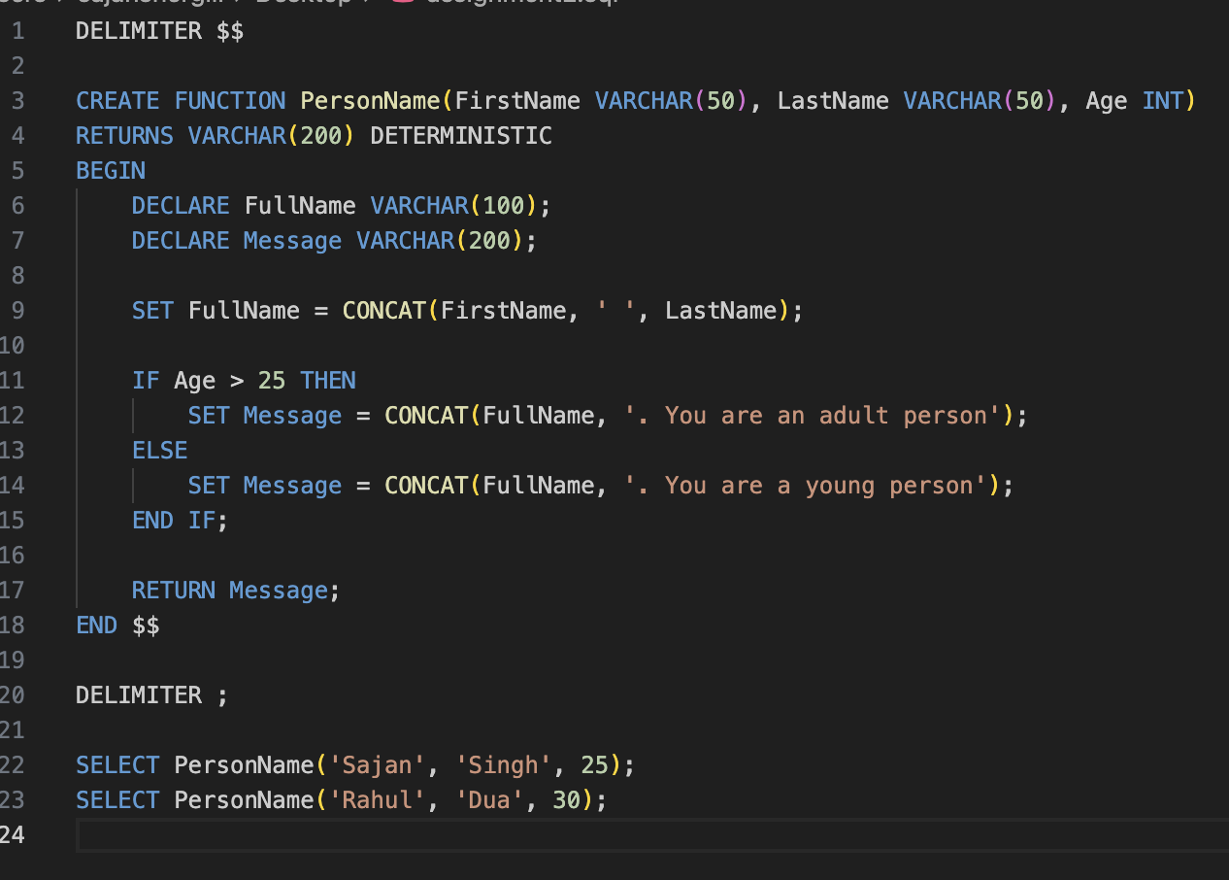

Output:-
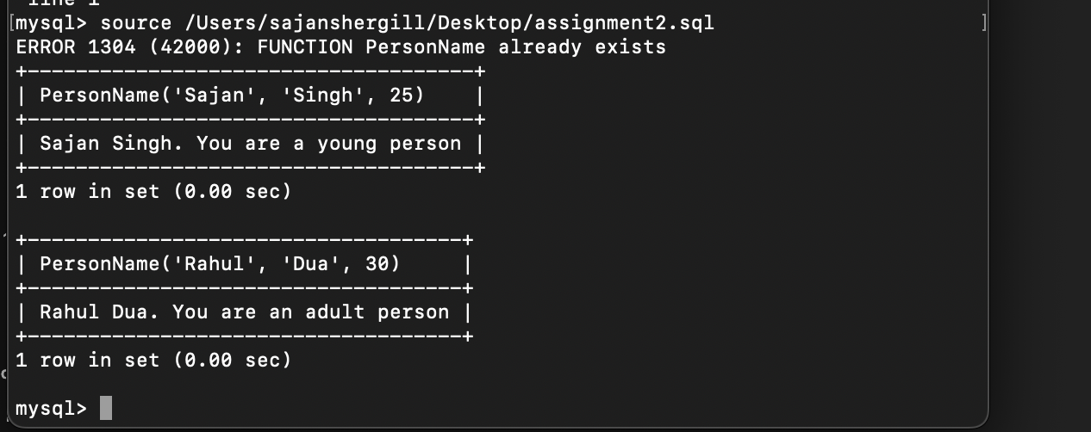

- Create the function average5 which accepts 5 integer parameters and returns their average.
Call your function average5 with the parameters 1,2,3,4,5

Code:-
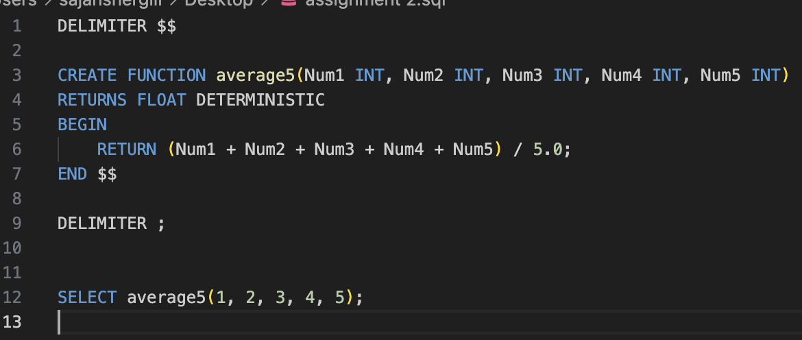

Output:-
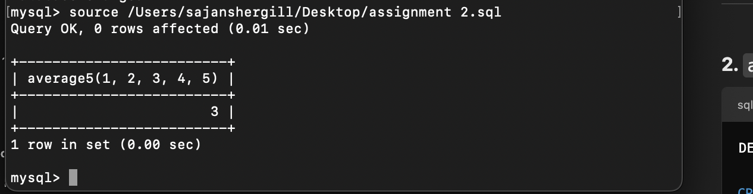

- Create the function varianceA which accepts a single numeric parameter (A) and calculates the variance of the numbers 1 to A. Hint: Probably, you will want to call the second function inside this one.
Call the function with the parameter 5

Code:- 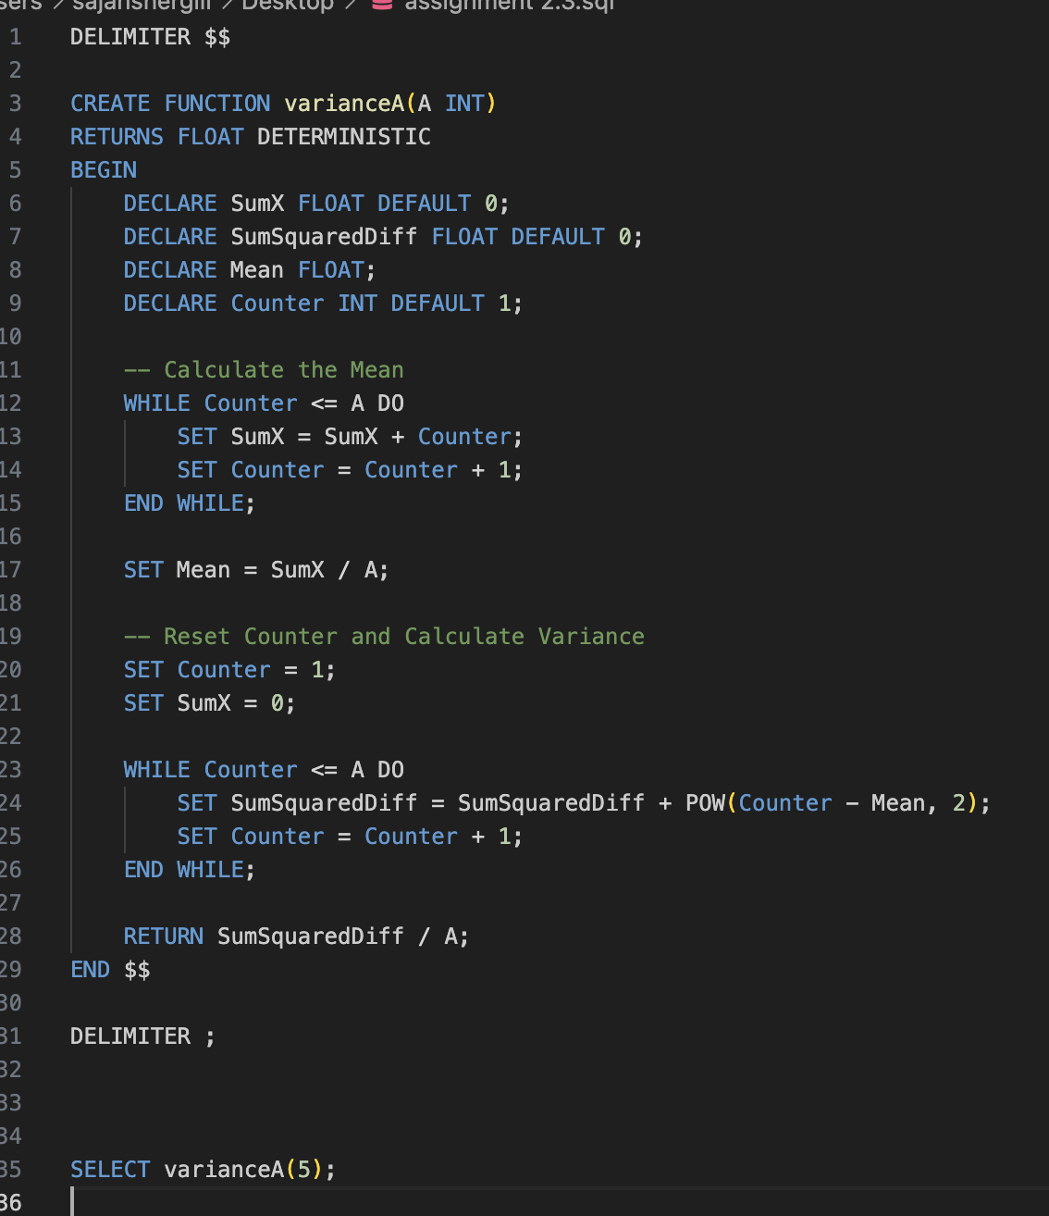


Output:-
